|  |  |
| --- | --- |
| Section |  |
| Bench No. |  |

ECE110 Introduction to Electronics

Experiment 9 : Coupling Balance with Speed Control & Navigation

Name: Yao Yijiang

Student ID: 3230111876

Instructor: Li Si

____________________________

Date: 2024.4.16

____________________________

Teammate/Student ID 3230110840

____________________________

This part is reserved for your instructor

|  |  |
| --- | --- |
| Score |  |
| Instructor Signature |  |
| Date |  |

**Learning Objectives**

 Deeper skills in building cascaded circuits.

 Use logical AND Coupling Balance with Speed Control.

**At Your Bench**

Modify your motor-control circuit as shown below to include an adjustable wheel-speed balance potentiometer combined with speed control. You should recognize the familiar motor- drive circuits as well as two oscillators and two copies of the logical AND.

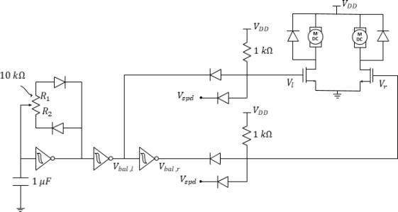

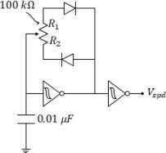

***Figure 1:*** *PWM-based wheel balancer plus speed control. The speed control circuit is drawn separately for*

*clarity, but notice that the nodes labeled* Ⅴspd ***must all be connected****.*

Use the oscilloscope to verify proper oscillation. Set both oscillators to an approximate duty cycle of 50%.

**Question 1:** Use the oscilloscope to measure the frequency of vbal,l. Record that frequency here.

Vbal = 176 Hz

Use the oscilloscope to measure the frequency of v spd. The frequency of v spd should be **8-**

**20 times higher** than the frequency of v bal,l. If it is not**, replace the** 0. 01 μF **capacitor with something more appropriate from your kit**. When you are satisfied with the frequency

of v spd, you may continue.

**Question 2:** Record the frequency of vspd here.

V spd = 1.786kHz

**Question 3:** Please use the oscilloscope to record the waveforms of VL and Vr and attach them here.

When called back to the breakout, you may race your cars in straight-line paths using the two potentiometers to adjust for both speed and wheel balance.

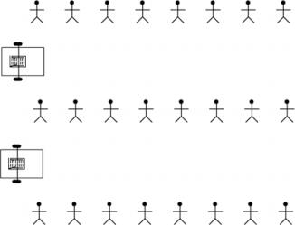

You are now ready to build a self-navigating vehicle. In the process, you have learned to model devices,predict behavior, build circuits, analyze circuit behavior, measure circuit parameters, and troubleshoot using the oscilloscope as a window into your work.

**Curb-Feeling Autonomous Vehicle**

Previously, youran the geared wheel motors using various methods, but always in “open loop” . That is, you didn’t use feedback. Now sensors will be used in feedback to control the speed of each wheel. Specifically, the snap-action switches will alter the feed of the pulse-width modulated (PWM) signals to control the speed of the car’smotors.

Your task is to complete the construction of an autonomous, wall-following robot car. The car must be able to drive through the corridor that has been built for it without getting stuck. One approach to accomplishing this design is to use the snap-action switches to *feel* the walls of the corridor and adjust the wheel speeds when the wallis close to one side of the car. The diagram below depicts an example corridor layout that your car should be able to navigate.

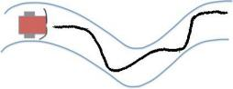

***Figure 2.****A curb-feeling (wall-avoiding) autonomous vehicle and its possible path through a tunnel.*

In this way, each snap-action switch acts as an interface with the environment around the car. When toggled, the switch has detected that an object (the wall) is near that side of the car. With this in mind, consider how we want the car to behave. In this particular design challenge, there are only three cases that are important to our control design.

***Table 1:*** *Important navigational conditions.*

|  |  |  |
| --- | --- | --- |
| 1 | Nowalls on either side | The car should drive straightforward |
| 2 | A wall on the left side | Car turns right (left wheel faster than right) |
| 3 | A wall on the right side | Car turns left (right wheel faster than left) |
| 4 | A wall in front | Pick vehicle up and start over |

Figure 3 introduces the addition of two snap-action switches. The snap-action switches will complete a so-called closed loop control system where the switches serve as an input to the car, changing the relative speeds of the motor and, therefore, also changing the distance of the sensors from a wall.

**Question 4:** Which sensor should be connected to the left wheel motor of the car, the left or the right sensor?

The right sensor.

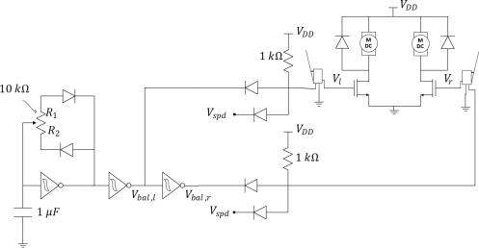

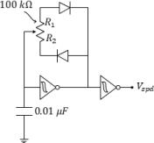

***Figure 3:*** *Adding snap-action switches for wall-following control.*

Fix the snap-action switches to the front of the car chassis with screws, as shown in Figure 4. With the sensors in place, connect them to your circuit as shown in Figure 3. Validate operation and then head to the breakout area to test and modify your circuit as needed. At the breakout area, you may run your car **along the edge of the cardboard**. Adjust the wheel balance that the car has a slight inclination to turn towards the left with the wall to left. Adjust the wheel balance that the car has aslight inclination to turn towards the right with the wall to right. Adjust the wheel speed as necessary for fast, but reliable control.

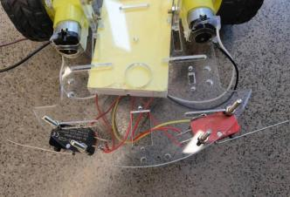

***Figure 4:*** *Before connecting the snap-action switches to your circuit, connect them to the car chassis.*

**Question 5:** Comment on the ease of altering the car to follow the wall on the right. Briefly explain the design of your circuit that made this possible.

When the car hits the wall, the left motor would turn off, turning the car left untill it is enough for the switch is on again.

**Question 6:** Demonstrate your solution to your instructor on the white wall with decreasing radius. Your instructor will initial the Summary page if satisfied with your design.

|  |  |
| --- | --- |
| ***For instructor use only:***  • demo was successful. | Instructor sign: |

**Question 7:**In the procedure prior to Question 2, if the frequency of vspd had been too low, should you have tried a (larger) 0.1 μF capacitor or a (smaller) 0.001 μF capacitor? Explain.

We try a smaller one. When capacitor is lower, it charges and discharges more quickly. Thus it has a higher frequency.

**Question 8:**Discuss why the frequencies of vbal and vspd need to be different. In doing so, also discuss what could go wrong if the two frequencies were the same but incoherent.

**HINT:** There are two figures below. The first has Vspd and Vbal with the same frequency, but “in phase” where they are both high around the sametime. The logical AND seems to make sense. Now sketch what the output of the logical AND would be when the two signals are

“out of synch” as in the bottom diagram...



***Figure 5****: The logical AND looks good when Vspd and Vbal are in “in synch”.*





***Figure 6****: Sketch the logical AND when Vspd and Vbal are “out of synch” above*

Because we need to reduce the influence of the balance waveform on the duty cycle of the speed waveform. If they are in the same frequency, they may form the situation in figure 6, making the duty cycle make lower than expected, affecting the overall speed fo the motor.



**Question 9:** In the space below, discuss briefly the many design elements of your car.

We use two circuits to balance and control the speed of the car. We can use an AND gate to form the final waveform. That is Vbal balance waveform and Vcpd speed waveform. Both of the two are generated by schmitt triggers and compacitors.

**Question 10:**Discuss with your peers ideas that would enhance the abilities of this vehicle. List these ideas along with the type of circuit behavior you would need to make these ideas a reality.

We can use infrared sensors to detect the distance of the wall, and then transfer the distance signal to digital signal like 0, 1 to control the direction of our car.

Congratulations! You have now successfully created an autonomous vehicle. In doing so, you have learned to use the oscilloscope as a developer’stool. You also have learned enough about circuits to consider doing your modifications to the vehicle. How about exploring the operation of infrared emitter/detector sensors to do “line-following” instead of “wall- following”? Perhaps, you could explore the operation of the ultrasonic sensor to avoid or even seek objects at some distance from the car? Or, perhaps you now have your own ideas for how you might start your own circuit project from scratch, incrementally exploring the sensors, circuits, cascading of circuits, and artistry required to design something brand new!

***Explore More!* Modules**

Explore More! Modules provide students with options to investigate new concepts! As time allows, do one or more of the modules before returning to the laboratory’s core procedure.

This week, we highly recommend the following ***Explore More! Modules:***

|  |  |  |
| --- | --- | --- |
| ***Explore More*! 8B The Clipping Circuit** | ***Explore More*! 7F: Schmitt Trigger IV** | ***Explore More*! 9B:**  **Voltage-Follower Buffer** |